D09 BY Data Profiling Report

Project: GSC E2E Data Enablement
100999765

Origin/Author : Sai Sharan Boddupally

Approved by :

Date Approved:

Document Purpose

The purpose of this Data Profile Report is to provide a comprehensive understanding of the source data that will be used to populate Blue Yonder, and to identify and address any data quality issues such as inconsistencies, inaccuracies and duplications before data is migrated.

The document will assist in the creation of any strategies for data cleansing and establishes a baseline for comparing data quality before and after migration, and additionally will identify any potential migration-related challenges.

Audience
Group / Team / Stakeholder | Focus Area
Program Technical Design Authority | Provides insight into the existing data schema, its quality and structure. This will form the basis of key design decisions relating to data risks associated with the migrations, planning any mitigations, and ensures that the completed data migration aligns with Imperial Brands data architecture principles.
Engineering Team | Provides guidance in creating a data mapping plan, bringing and understanding into the transformations needed, and enabling an accurate estimate of data cleaning and work effort and resources required.
Testing Services | Help the team assess the testing scope, enabling them to produce relevant test cases and test scripts for integration testing.
Business Stakeholders | Provide an overview of the data quality and any potential risks and complexity associated with the migration, to assist in understanding any potential implications for business processes.

Document Control
This document will be owned and maintained by the groups and members listed below. All version management and future changes must involve the owners listed below.

This Document Version | 0.1
Author | Sai Sharan Boddupally
Date Issued

Amendment History

Version | Date Created | Created/  Amended By | Approved/  Reviewed by | Change Detail
0.1 | 16-06-2023 | Sai Sharan Boddupally |  | Draft

Distribution
Put a copy on architecture intranet. Distribute a link to the following roles. You are not permitted to omit any role (except PM if not appointed yet):

Recipient | Role
Remi Guillon | Project Sponsor
Erik Lenz | Head of Supply Chain Excellence
Jessica Bolte | Project Manager
Benjamin Bruhn | Head of Supply Chain Enablement
Maciej Grebski | Head of Demand Planning
Lesya Toryanyk | Demand Planning Transformation Manager
Jan Eismann | E2E SC Planning Solutions Manager
Marion Weber | Manager E2E Business Processes Master Data
Mohamed Khalifa | IT Business Partner
Steve Dickason | Head of Data Strategy, Governance & Architecture
Lalit Kapur | Data Project Manager
Patrice Gourlet | Head of Data Architecture
Javier Romero Blazquez | Head of Data Platforms
Sumanta Dutta | Data Architect

Document Sign-Off
Where relevant this document has been received and reviewed by the following people. Sign off via email to the solution architect indicates the document has been reviewed and the proposed solution is acceptable for the sections indicated.

Name | Role | Date received | Approving sections | Signoff
Maciej Grebski | Head of Demand Planning
Lesya Toryanyk | Demand Planning Transformation Manager
Jan Eismann | E2E SC Planning Solutions Manager
Marion Weber | Manager E2E Business Processes Master Data
Sumanta Dutta | Data Architect
Lalit Kapur | Data Project Manager

Contents
Amendment History 3
Distribution 3
Document Sign-Off 3
1. Background & Scope 6
1.1. Scope 6
1.2. Out of Scope 6
1.3. Assumptions 7
1.4. Dependencies 7
1.5. Known Issues 7
2. Profiling Summary 8
2.1. Approach 8
3. Data Profiling Approach 9
3.1. Tactical Approach 9
3.2. Mapped Entities 9
4. Data Profiling Results 10
4.1. BOM 10
4.2. CUSTOMERORDERS 10
4.2.1. T31B Interface 10
4.2.2. T38 Interface 10
4.3. DDSOURCING_M11 10
4.4. FORECAST_T20 10
4.5. HIST_SALESORDER_T01 11
4.6. HIST_SHIPMENTS_T01 11
4.7. INTRANSIT(TRANSPORTLOAD) 11
4.7.1. T03 Interface 11
4.7.2. T35 Interface 11
4.8. INVENTORYONHAND 11
4.8.1. T03 Interface 12
4.8.2. T35 Interface 12
4.9. ITEM 12
4.10. ITEM_LOCATION 12
4.10.1. M01 Interface 12
4.10.2. M01N Interface 12
4.11. ITEMUNITCONVERSION 13
4.11.1. M01 Interface 13
4.11.2. M01N Interface 13
4.12. LOCATION_M35 13
4.13. NETWORK 13
4.14. PRODUCTIONORDER_T34B 13
4.15. PURCHASEORDER 14
4.15.1. T37 Interface 14
4.15.2. T31A Interface 14
4.16. RESOURCE_M34 14
5. Next Steps 15
6. Appendices 16
6.1. Code Library 16
6.1.1. Create Mount Point 16
6.1.2. Read Sample Files as Data frame and returns Total Count 16
6.1.3. Null Value Check 16
6.1.4. Unique Values 16
6.1.5. Data Format Validation 16
6.1.6. Invalid Values 17
6.1.7. Duplicated Entries 18
6.2. Glossary Of Terms 18

Background & Scope
Within Imperial Brands there is a need for a Data Hub to underpin the objective of providing a central data repository for managing and integrating corporate data assets.
The vision of the Data Hub is to be a global data platform for the unification of data integration activities and to provide modern processing capabilities on a flexible cloud-based platform.
The purpose of this document is to show extension of the Datahub from a high-level that show flows of datasets flowing into and out of the Data Hub and how the data will be structured within the Data Hub for the supply chain planning (SCP) solutions from Blue Yonder (BY).

Scope
Following BlueYonder entities which were identified as required to enable Demand Planning within the BlueYonder system and shows all the source of sample files that were requested for the system. Suitable Sample Files were not received for the entities highlighted yellow and could not be profiled.

Interface(s) |  | BY Entity Name
M32 |  | BOM
T31B | T38 | CUSTOMERORDERS
M11 |  | DDSOURCING
Data Hub -T20 |  | FORECAST
T01 |  | HIST_SALESORDER
T01 |  | HIST_SHIPMENTS
T03 | T35 | INTRANSIT (TRANSPORTLOAD)
T03 | T35 | INVENTORYONHAND
Data Hub |  | ITEM
M01 | M01N | ITEMLOCATION
M01 | M01N | ITEMUNITCONVERSION
M01 | M01N | ITEMLOCCUST
M35 |  | LOCATION
M-11 |  | NETWORK
T34B |  | PRODUCTIONORDER
T37 |  | PURCHASEORDER
T31A |  | PURCHASEORDER
M-34 |  | RESOURCE

Out of Scope

The following Entity/Interface pairings are out of scope for this document because the interfaces do not exist or could not be accessed, and no files were provided.

BY Entity Name | Interface(s)
CONFIRMED FORECAST | T22
CUSTOMERORDERS | CIF
DDSOURCING | M11n
INVENTORYONHAND | CIF
NETWORK | M-11N
Plan Prod Order | T34a
Purchase Req | t-36

In addition, any entity or interfaces not included in the above tables, are out of the scope of this document.

Assumptions

Ref. | Assumption
A01 | The client will ensure that enough storage is provisioned for storing that is getting loaded, processed, and archived.
A02 | All source systems that provide data extract in an agreed file format for the same interface ID, they will keep column name, column order, number of columns, data type, number, and date format the same in the file.

Dependencies
Ref. | Assumption
D01 | The Client shall provide sample data files as per RES06 from the SOW.

Known Issues
Ref. | Issue | Impact | Mitigation
R01 | All source data owners not known or communicated. | High | Imperial must identify source system owners and IT SME contact detail and provide this information
R02 | Unconfirmed guidelines for preparing the solution. | High | Need confirmed approach to minimise in duplication of efforts
R03 | Unavailability of sample data | Medium | Avail sample data for entity / interface combination

Profiling Summary

Approach
To facilitate demand planning within the Blue Yonder system, we identified a total of 17 entities which were populated by total of 17 interfaces. Several entities were populated by multiple interfaces, giving a total of 26 datasets in scope. Over a period of several weeks, we received sample data in multiple formats, our objective was to associate these sample files with the 26 datasets and apply data profiling on them.

- Out of these datasets in scope, we successfully mapped 24 datasets to the sample files received. The three datasets we were unable to map, are as follows:
  - DDSOURCING(M11)
  - NETWORK(M11)

- Of these 24 datasets, 2 sample files received has data issues and as a result, we are not able to profile them.
  - BOM (M32)
  - PURCHASEORDER (T37)

- For the remaining 22 datasets, we extracted the required columns and mapped with corresponding sample file columns.

- The vast majority of interfaces provided we were unable to map every required field.

- For the required columns which we were able to map, data profiling was carried out and further details are available in Section 4 of this document.

- For some of the sample files received, we were unable to determine which interface was responsible for creating the file.

- The first set of sample files we received did not include column headers. This made it challenging to understand the data source and establish mapping.

Data Profiling Approach

Tactical Approach

Our approach to data profiling was to create a new notebook in the existing Azure Development Environment that exists for Noodle. We created new notebook(create data profile report) under user PCAPSOB@imptobnet.com. We ingested all sample files received into a newly created Azure Blob Storage Container named ‘webmethods-samplefiles’ within the Azure Data Lake Storage.

Once ingested, the sample files were accessed by Azure Databricks Service and we performed data profiling using code written in Pyspark (see section 6.1). We mapped the sample file columns with the associated fields identified within Blue Yonder as per the activities performed by the Data Mapping Team (Refer to D05 for the Data Catalogue).

The data was profiled in line with the following checks as identified within the SOW:

- Data Completeness – NULL or missing values
- Data Format (text in numerical fields, multiple decimal points, telephone numbers with text)
- Values out of range (dates in incorrect format, non-existent days or months, negative transaction values)
- Duplicate Data

Mapped Entities
The following sample datasets were received and mapped to the relevant Blue Yonder entities:

All Sample Data Files received can be found here: Sample files

Data Profiling Results
The sample files which are mapped to Blue Yonder entities have been profiled in the following pages. We have created a table for each entity, and identified all of the mandatory columns, the field from the sample file that relates, and the number of records provided within the sample dataset. We have also identified any NULL values and any non-unique records, as well as if the data format was in line with requirement.

For a full breakdown of the data profiling results, please refer to the D09 Data Profiling Summary spreadsheet as this contains additional details.

BOM
The BOM (Bill of Materials) entity within BlueYonder serves a crucial purpose in managing and representing the hierarchical structure of a product's components and sub-components. The BOM entity defines the relationship between the finished product and its associated parts or materials needed for manufacturing.

Sample file provided for this interface but the It contains single line items and not sufficient for the data profiling process.

CUSTOMERORDERS
The BlueYonder CUSTOMERORDERS table details every line item for every order from all customers. All Sales Orders (Customer Orders) should be sent to BlueYonder. These are considered to be confirmed demand for planning and are high priority.

T31B Interface

We found no data issues with the data provided within the Sample file. 6 fields identified as mandatory by BlueYonder all of them were mapped with sample file column
Our profiling identified that the non-required field Quantity has some negative transaction values – however, these could be legitimate.

Full results of data profiling can be found in the excel sheet CUSTOMERORDERS_T31B

T38 Interface
6 fields identified as mandatory by BlueYonder. 6 out of 6 were mapped with sample file columns. However, Same file for this dataset is provided but most of them are single recorded files.
Upon profiling the T-38 interface sample file, we found no data issues, 6 fields identified as mandatory by BlueYonder and all of them are mapped with sample files columns.

DDSOURCING_M11
DDSourcing in Blue Yonder defines the sourcing relationships that Dynamic Deployment considers when it tries to resolve shortages at individual SKUs within an item family. These sourcing is not used in regular planning and are used only for inventory rebalancing purposes.

The DDSourcing datasets are sourced from MDM database for finished goods (M11)

Sample file for this dataset is not provided and couldn’t map and profile.

FORECAST_T20
The data category Forecast includes the forecast received as input. The input can be used as one of the measures in the consensus process or it can be used to load the SKUExternalFcst in SCPO or can be used to load the Attach rate from customer.

Upon profiling the FORECAST_T20 sample file, we found no data issues. 6 fields identified as mandatory by BlueYonder. However, 1 field is not present in the sample file and could not be mapped.

Full results of data profiling can be found in the excel sheet FORECAST_T20

HIST_SALESORDER_T01
The BlueYonder entity Hist_SalesOrder provides a history of all closed sales orders that have been closed.

Upon profiling the HIST_SALESORDER sample file, we found no data issues, 4 fields identified as mandatory by BlueYonder. However, 1 Field is not present in the sample file and could not be mapped.

Full results of data profiling can be found in the excel sheet HIST_SALESORDER_T01

HIST_SHIPMENTS_T01
The Entity Hist_Shipments details historical shipments that have been made.

Upon profiling the HIST_SHIPMENTS sample file, we found no data issues with the data provided, however 4 out of 7 fields required by BlueYonder were not present in the sample file and could not be mapped.

Full results of data profiling can be found in the excel sheet HIST_SHIPMENTS_T01

INTRANSIT(TRANSPORTLOAD)
The BlueYonder Entity INTRANSIT includes all the in-progress intra-company shipments, for example stock movements between warehouses. We were advised that this entity could be populated by a combination of the outputs from T03 and T05 interface.

T03 Interface
Upon profiling the T03 sample file, we found no data issues with the data provided, however 3 out of 5 fields required by BlueYonder were present in the sample file and as a result it appears this entity cannot be populated by the interface identified.

However, we carried out data profiling on sample file received as it was mapped to this interface.

Full results of data profiling can be found in the excel sheet INTRANSIT(TRANSPORTLOAD)_T03

T35 Interface
Upon profiling the T35 sample file, we found no data issues with the data provided, however only 1 out of 5 fields required by BlueYonder were present in the sample files provided, and as a result the majority of the entity cannot be populated by the interface.

Full results of data profiling can be found in the excel sheet INTRANSIT(TRANSPORTLOAD)_T35

INVENTORYONHAND
This defines data of the stock quantity of a specific product in a specific location for a given day, counted or in general determined at a given point in time.

T03 Interface
Upon profiling the T03 sample file, we found no data issues with the data provided, however none of fields required by BlueYonder were present in the sample file and as a result it appears this entity cannot be populated by the interface identified.

However, we carried out data profiling on sample file received as it was mapped to this interface.

Full results of data profiling can be found in the excel sheet INVENTORYONHAND_T03

T35 Interface
Upon profiling the T03 sample file, we found no data issues with the data provided, however only one out of 3 fields required by BlueYonder were present in the sample file and as a result it appears this entity cannot be populated by the interface identified.

Full results of data profiling can be found in the excel sheet INVENTORYONHAND_T35

ITEM
The Item Entity with Blue Yonder (BY) is the main collection of products or materials that are part of the inventory within the Supply Chain. These can be a Finished Product (FG), a component, a Raw Material, or any other tangible or intangible item that needs to be managed and tracked within the supply chain.

At the outset, it was observed that the ITEM entity originates from two interfaces, namely M01 and M01N. Data profiling was conducted on the sample files associated with these interfaces. Jan has notified us that the interfaces for the ITEM entity have been modified, and the new interface will be confirmed soon. We are currently awaiting the confirmation of the new interfaces.

The ITEM entity resides in the datahub as ITEM_MASTER table. Upon profiling the ITEM sample file, we found that ‘PLANNING_SKU_CODE and PLANNING_SKU_NAME’ values are found to be identical. In addition, 117 entries exceed the maximum 50-character length imposed by BlueYonder.

In addition, there were 5 out of 13 fields that are required by BlueYonder which do not exist within the sample file and cannot be mapped.

Full results of data profiling can be found in the excel sheet ITEM_DATAHUB

ITEM_LOCATION
The Item_Location entity within BlueYonder is used for Stock Keeping purposes. It defines combinations of item and location and contains data about a stock-keeping unit or SKU (specific item stored in a specific location). This dataset is sourced from MDM database for finished (M01) and non-finished goods (M01N).

M01 Interface
Upon profiling the ITEM_LOCATION_M01 sample file, we found no data issues with the data provided.

Full results of data profiling can be found in the excel sheet ITEM_LOCATION_M01

M01N Interface
Upon profiling the M01N sample file, we found no data issues with the data provided.

Full results of data profiling can be found in the excel sheet ITEM_LOCATION_M01N

ITEMUNITCONVERSION

The ITEMUNITCONVERSION entity interfaces with the M-01 and M-01N files within Imperial Brands.

M01 Interface

Upon profiling the ITEM_UNITCONVERSION_M01 sample file, we found no data issues with the data provided, however only 1 out of 6 fields that are required by BlueYonder were present in the sample file as a result it appears this entity cannot be populated by the interface identified.

Full results of data profiling can be found in the excel sheet ITEM_UNITCONVERSION_M01

M01N Interface
Upon profiling the M01N sample file, we found no data issues with the data provided, however none of the mandatory fields that are required by BlueYonder are present within the sample file and as a result this cannot be used to populate this entity.

However, we carried out data profiling on sample file received as it was mapped to this interface.

Full results of data profiling can be found in the excel sheet ITEM_UNITCONVERSION_M01N

LOCATION_M35
A Location within BlueYonder contains details of physical locations. Generally, these could be references to storage locations within a Warehouse or WIP area in factory floor.

Upon profiling the LOCATION_M35 sample file, we found no data issues with the data provided, however 2 out of 5 mandatory fields that are required by BlueYonder do not exist within the sample file and cannot be mapped.

It is also noteworthy that M35 file provided refers specifically to VendorLocation. We have been advised that additional Location files will be provided in due course.

Full results of data profiling can be found in the excel sheet LOCATION_M35

NETWORK
The Network entity plays a crucial role in supply chain and logistics management within Blue Yonder. It helps in modeling and optimizing the flow of goods, resources, and information across the network, enabling efficient planning, execution, and monitoring of supply chain operations.

By defining the network infrastructure, the Network entity facilitates accurate demand forecasting, inventory management, order fulfillment, and transportation planning.

Sample file for this dataset is not provided. We could not carry out the profiling process.

PRODUCTIONORDER_T34B
The Production Orders entity represents a firm production plan and work in progress at different stages of production. These orders serve as future supplies available for planning purposes. The commitments from the Plant are typically within the manufacturing firm's horizon.

The work in progress production orders can be further elaborated in terms of completed quantities, quantities in production, and other relevant details.

Sample file for this dataset is not provided. We could not carry out the profiling process.

PURCHASEORDER

It defines open purchase orders with a supplier.

T37 Interface

The Purchase_Orders dataset is sourced from LQAD database using interface id: T37.

T31A Interface
none of the mandatory fields that are required by BlueYonder are mapped to the sample file column as this file is received on 11/07/2023 and we could not map.

However, we carried out profiling on PURCHASEORDER_T31A sample file, we found Quantity column contains negative transaction values.

RESOURCE_M34
A Resource within BlueYonder contains the details of a machine, labor pool, subordinate material, or other resource used in the production or transport of products.

Upon profiling the RESOURCE_M34 sample file, we found no data issues with the data provided and 3 out of 3 fields that are required by BlueYonder were present within the sample file.

Full results of data profiling can be found in the excel sheet RESOURCE_M34

Next Steps

We identified several concerns during the Data Profiling process with the data provided through the WebMethods interfaces as currently used by Imperial Brands.

- Several interfaces did not provide any of the mandatory fields as required by Blue Yonder.
- The majority of the interfaces only provided a low proportion of the mandatory fields required.
- The format of some interfaces means that only single records were provided, and we were not able to fully profile the data.
- Sample files for some interfaces [could not be / were not] provided.

As a result, the following recommendations should be reviewed in order to ensure maximum effectiveness in the planned works:

- Improve the existing interfaces to add missing data fields.
- Consider creating new interfaces to provide the missing data.
- Alter the format of some data files (XML) to provide more than single entries.
- Identify a Data Owner who can be contacted to provide better quality data files.
- Provide alternative ways to get data from systems, such as pulling data directly from source systems rather than obtaining via the existing WebMethods interface.

Appendices

Code Library
As part of the data profiling, a comprehensive series of functions were created within Azure DataBricks. Detailed here are the key functions created and that are available within the Development DataBricks environment.

Create Mount Point
To create the mount point from Databricks to ADLS (Azure Data Lake Storage),
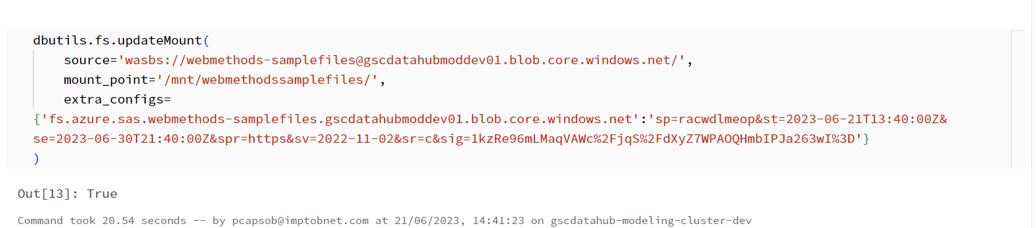

Read Sample Files as Data frame and returns Total Count
To read the sample files from ADLS as Data frame and also returns total count,
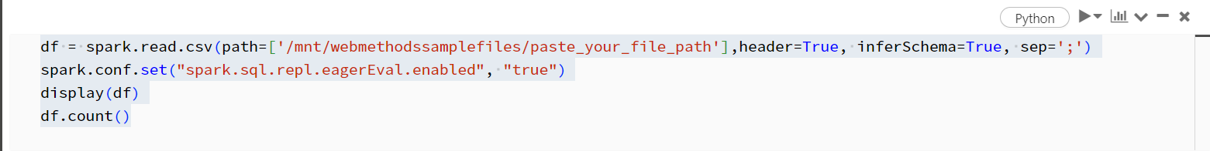

Null Value Check
To check null values,
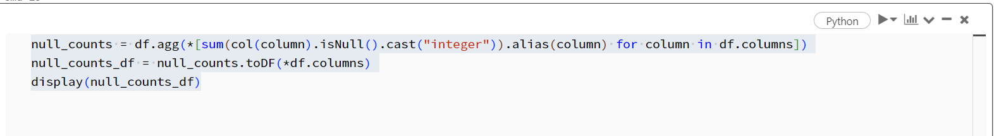
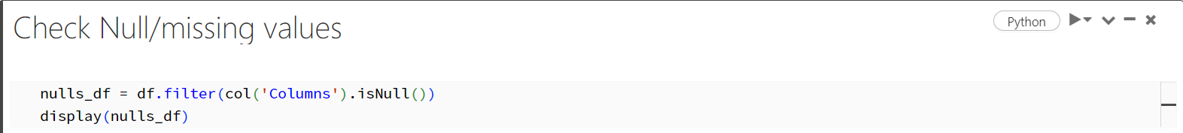

Unique Values
To check Unique Records,
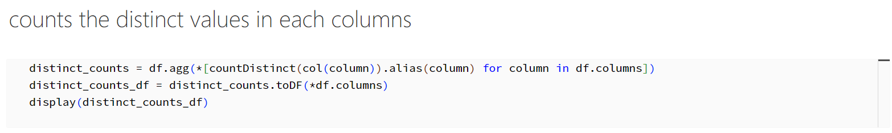

Data Format Validation

To check data format checks (Texts in numerical column, multiple decimals),
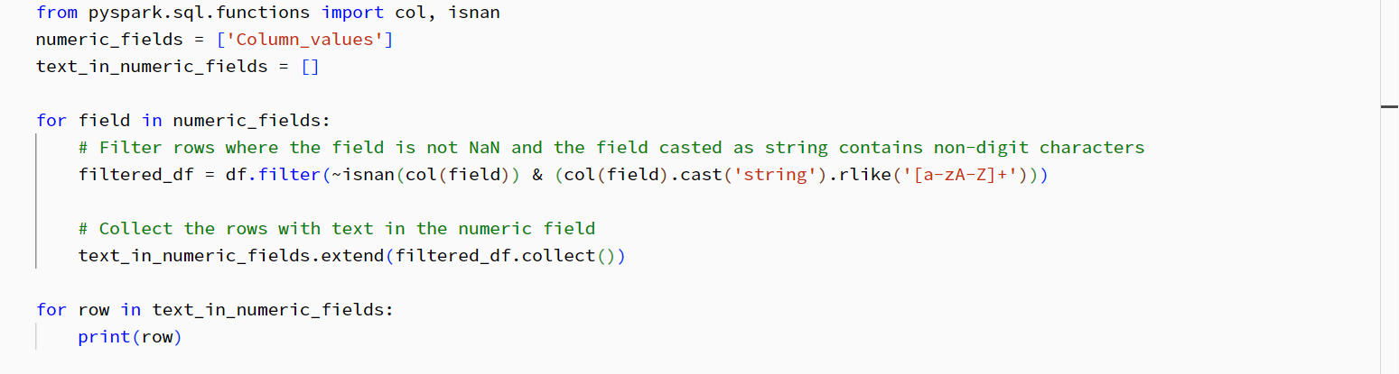
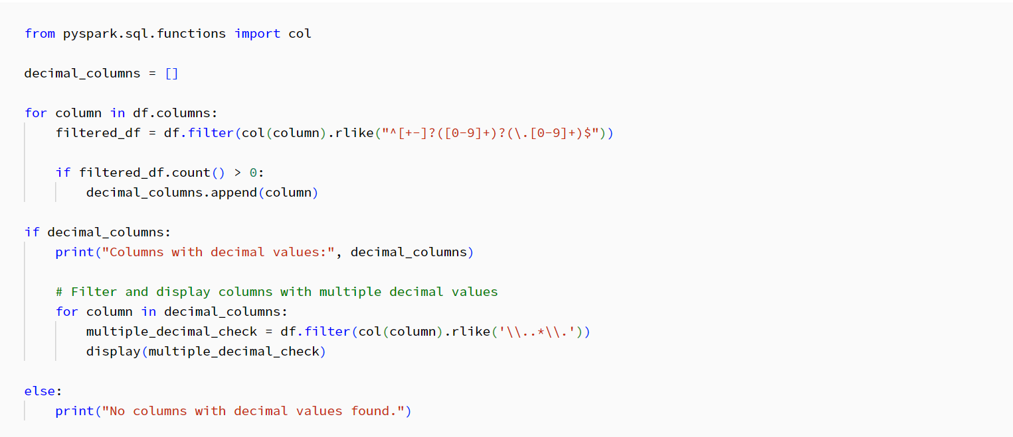

Invalid Values
To check values out of range (dates in incorrect format, non-existent days or months, negative values),
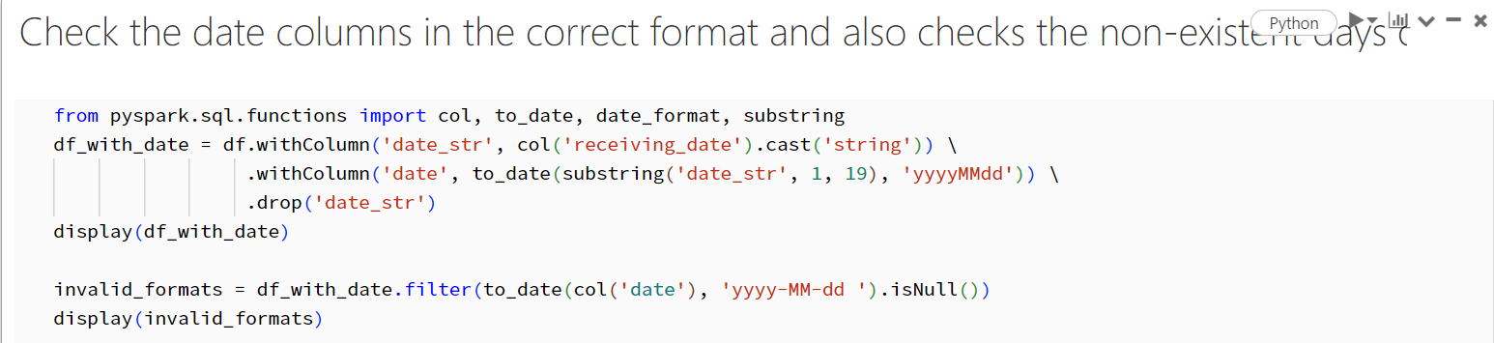
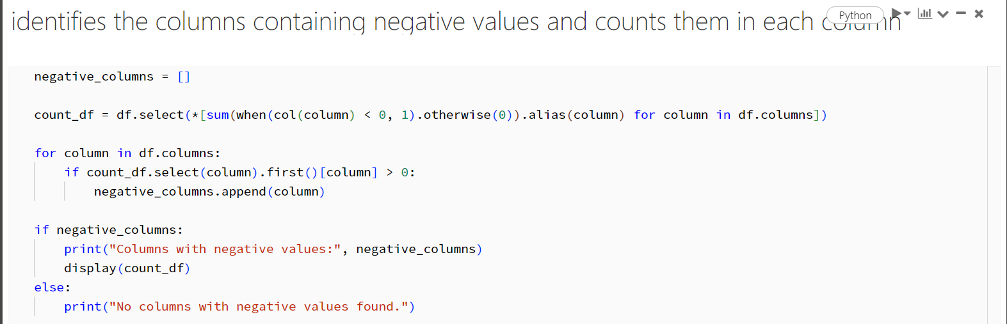

Duplicated Entries
To check duplicates,
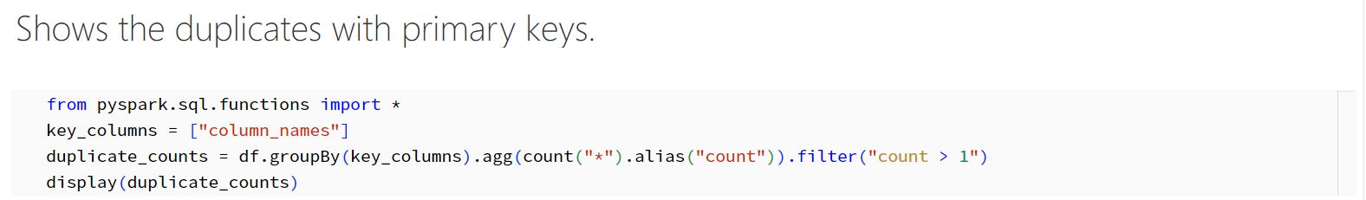

Glossary Of Terms

The table below describes generally used data terminology and terms specific to this project.
Term | Definition
ACID | Atomicity, Consistency, Isolation, and Duration
ADLS | Azure Data Lake Storage
AI | Artificial Intelligence
Append | Process of adding new data elements to an existing table
APO | Imperial Brands Enterprise Resource Planning solution
BI | Business Intelligence
BY | Blue Yonder
CSV | Comma-Separated Values
DB | Database
DBMS | Database Management System
DDL | Data Definition Language
Delta | New data that has been added to a table since the last load
Data Hub | Imperial Brands Data Platform leveraged to support Demand Planning
DML | Data Manipulation Language
DM | Data Mart
DP | Demand Planning
DQ | Data Quality
DRP | Distribution Requirements Planning
DW | Data Warehouse
EDW | Enterprise Data Warehouse
ELT | Extract, Load and Transform
ERD | Entity Relationship Diagram
ETL | Extract, Transform and Load
FK | Foreign Key
GDPR | General Data Protection Regulation
Hive | Imperial Brands Sales Data Lake
JSON | JavaScript Object Notation
KPI | Key Performance Indicator
LOB | Line of Business
MDM | Master Data Management
ML | Machine Learning
MOLAP | Multi-dimensional Online Analytical Processing
ODBC | Open Database Connectivity
ODS | Operational Data Store
OLE DB | Object Linking and Embedding Database
OLTP | Online Transactional Processing
PBI | Power BI
PK | Primary Key
QAP | Test APO
RDBMS | Relational Database Management System
ROLAP | Relational Online Analytical Processing
SCD | Slowly Changing Dimension
SCP | Supply Chain Planning
Snapshot | Point-in-time copy of a dataset
SQL | Structured Query Language
UOM | Unit of Measure
WAMP | Weighted Average Market Price
WAPP | Weighted Average Market Price

